**Assignment – 4**

**Normalization**

**Initial Jobs Database Schema:**

The ER diagram is as shown below.

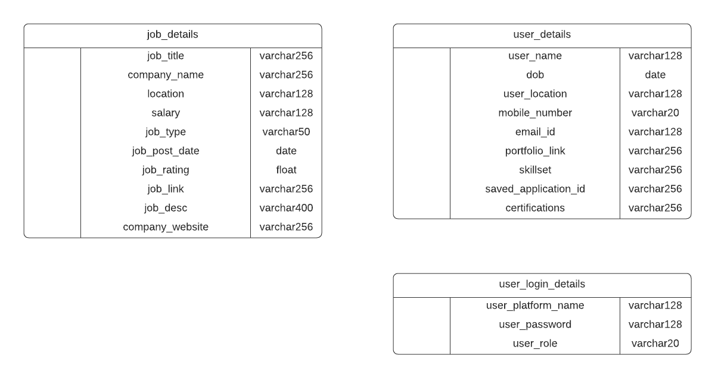

**Fig 1: Initial Schema**

Below is the sample screenshot of how the data inserted into the above tables looks like

**Schema and table:**

conn = sqlite3.connect('JobsFinalDatabase.db')

print("Opened database successfully");

conn.execute('''DROP TABLE IF EXISTS job_basic_details;''')

conn.execute('''CREATE TABLE IF NOT EXISTS job_basic_details

(

job_title TEXT,

company_name TEXT,

location TEXT,

salary TEXT,

job_type TEXT,

job_post_date datetime,

job_rating Float,

job_link TEXT,

job_desc TEXT,

company_website TEXT

);''')

print("job_basic_details Table created successfully");

conn.close()

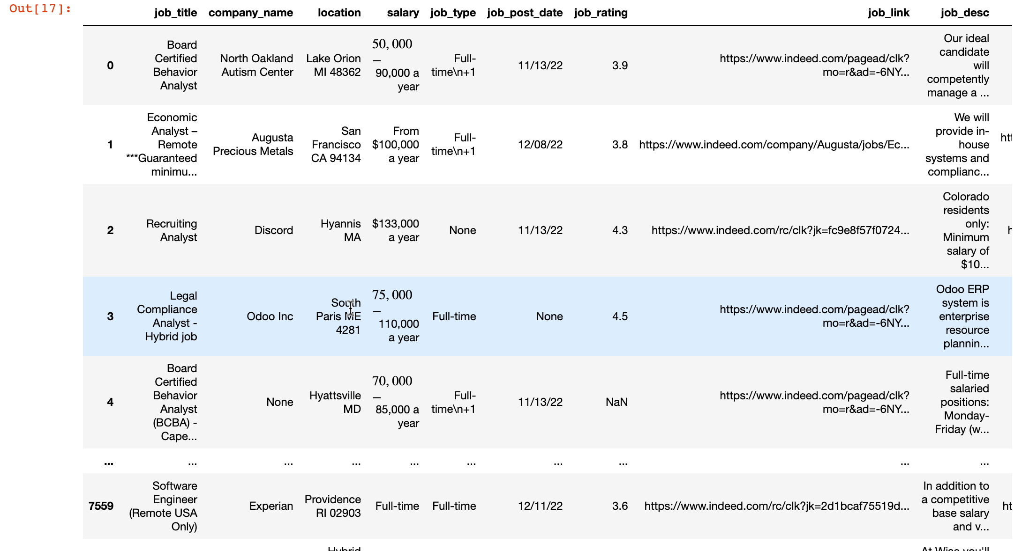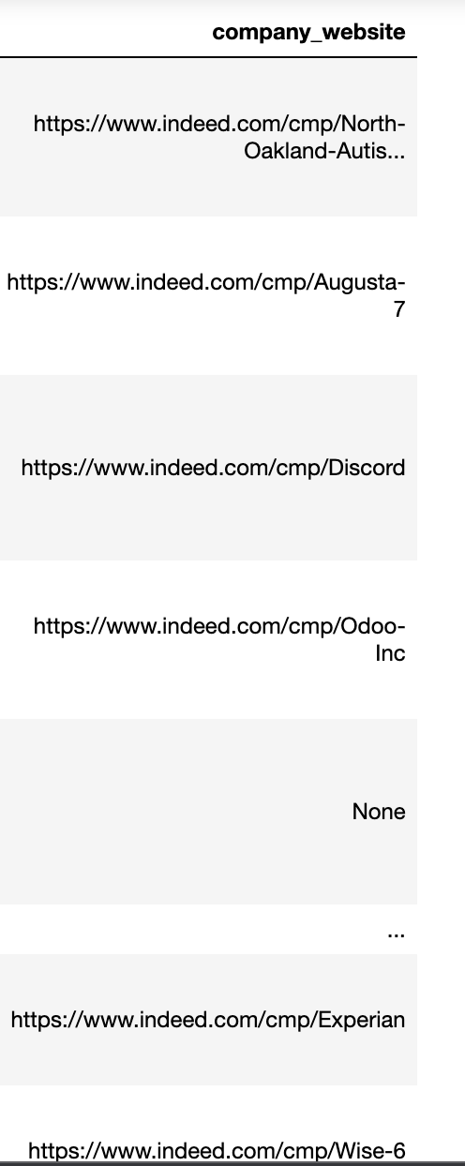

**Fig 2: Initial Schema Table 1**

conn = sqlite3.connect('JobsFinalDatabase.db')

print("Opened database successfully");

conn.execute('''DROP TABLE IF EXISTS user_basic_details;''')

conn.execute('''CREATE TABLE IF NOT EXISTS user_basic_details

(

user_name TEXT ,

dob datetime,

user_location TEXT,

mobile_number TEXT,

email_id TEXT,

portfolio_link TEXT,

skillset TEXT,

saved_application_id TEXT,

certifications TEXT

);''')

print("user_basic_details Table created successfully");

conn.close()



**Fig 3: Initial Schema Table 2**

conn = sqlite3.connect('JobsFinalDatabase.db')

print("Opened database successfully");

conn.execute('''DROP TABLE IF EXISTS user_login_basic_details;''')

conn.execute('''CREATE TABLE IF NOT EXISTS user_login_basic_details

(

user_platform_name TEXT ,

user_password TEXT,

user_role TEXT

);''')

print("user_login_basic_details Table created successfully");

conn.close()

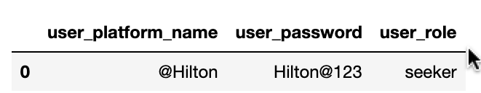

**Fig 4: Initial Schema Table 3**

Here the data is not normalized and has high chances of losing data integrity and potential duplication of data. Hence, normalizing the existing schema using the First Normal Form(1NF).

**First Normal Form (1NF):**

Every column in the table must be unique. Separate tables must be created for each set of related data. Each table must be identified with a unique column or concatenated columns called the primary key.

The existing data contains the location column that can be further reduced into city, state, and zip code. The salary column contains the min and max range of estimated pay for a particular job role. This can be further reduced to min salary and max salary.

Similarly, the location column in the user_details table can also be broken down into city, state and zip code.

user_details table has multiple skill sets, certifications, saved applications. This can be further reduced using the foreign keys as shown below.

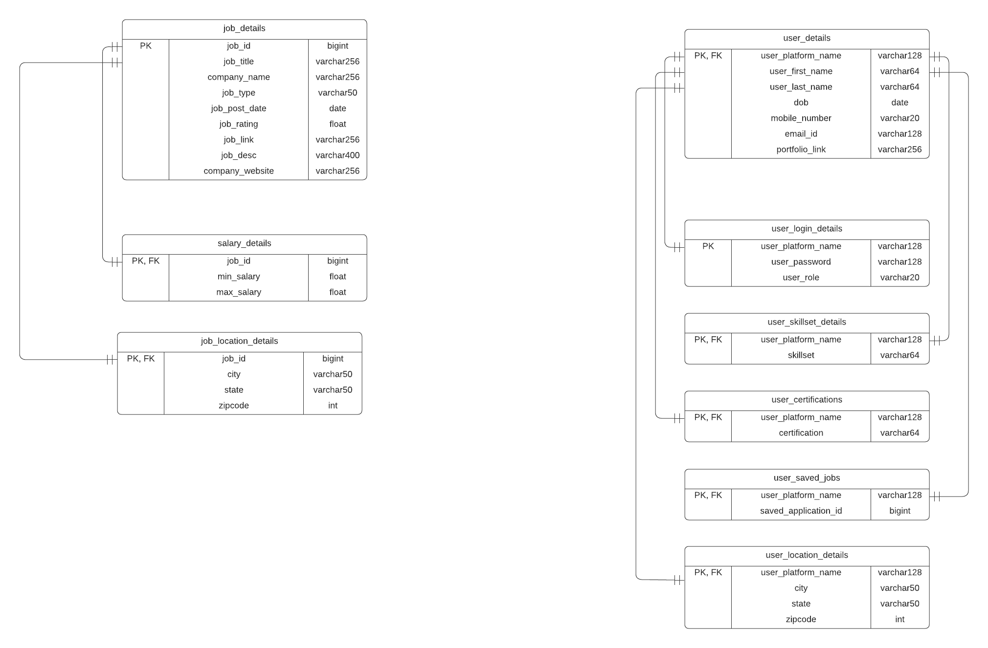

**Fig 5: 1NF Schema**

**Schema and table:**

conn = sqlite3.connect('JobsFinalDatabase.db')

print("Opened database successfully");

conn.execute('''DROP TABLE IF EXISTS job_details;''')

conn.execute('''CREATE TABLE IF NOT EXISTS job_details

(

job_id INTEGER PRIMARY KEY,

job_title TEXT,

company_name TEXT,

job_type TEXT,

job_post_date datetime,

job_rating Float,

job_link TEXT,

job_desc TEXT,

company_website TEXT

);''')

print("job_details Table created successfully");

conn.close()

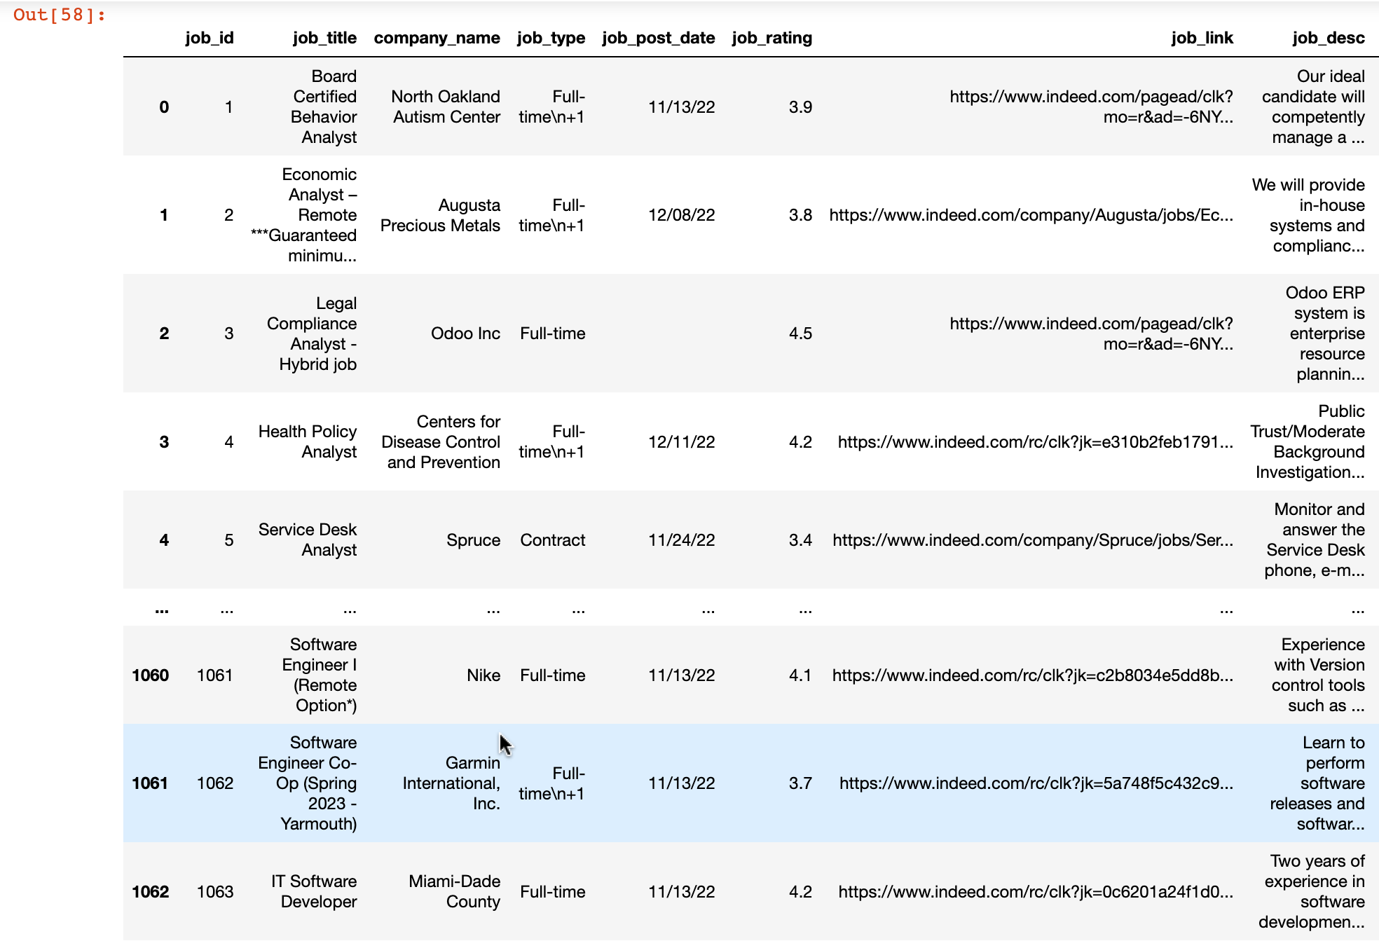 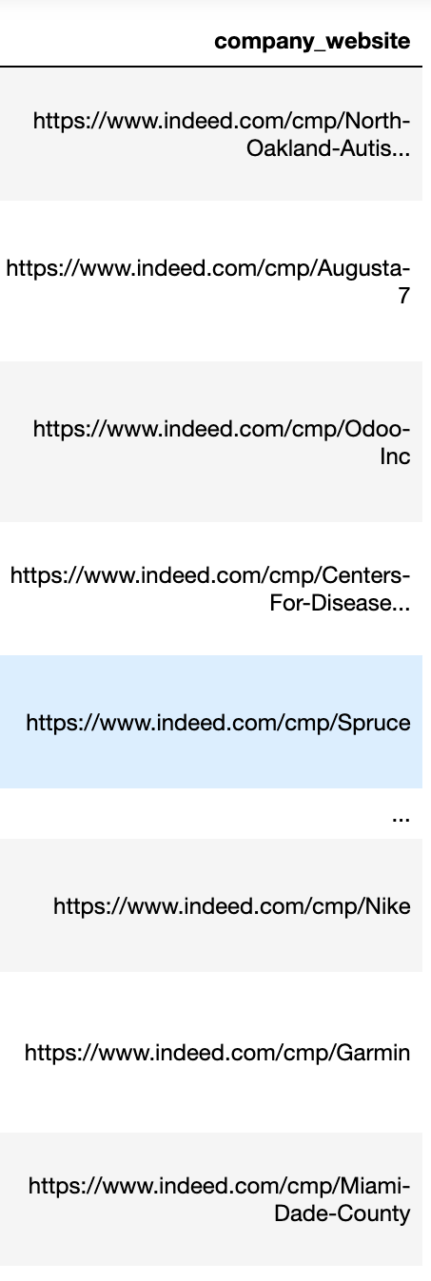

**Fig 6: 1NF table 1**

conn = sqlite3.connect('JobsFinalDatabase.db')

print("Opened database successfully");

conn.execute('''DROP TABLE IF EXISTS salary_details;''')

conn.execute('''CREATE TABLE IF NOT EXISTS salary_details

(

job_id INTEGER PRIMARY KEY ,

min_salary Float,

max_salary Float,

FOREIGN KEY (job_id) REFERENCES job_details(job_id)

);''')

print("salary_details Table created successfully");

conn.close()

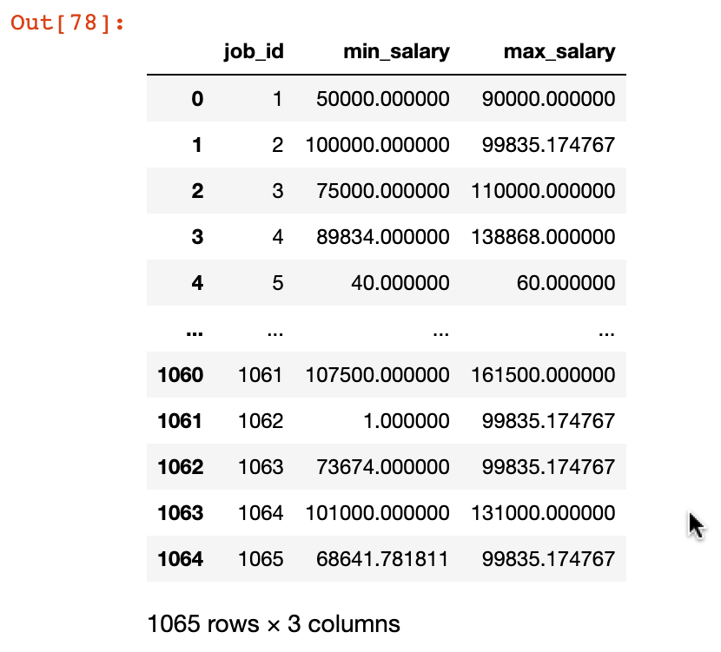

**Fig 7: 1NF Table 2**

conn = sqlite3.connect('JobsFinalDatabase.db')

print("Opened database successfully");

conn.execute('''DROP TABLE IF EXISTS job_location_details;''')

conn.execute('''CREATE TABLE IF NOT EXISTS job_location_details

(

job_id INTEGER PRIMARY KEY ,

city TEXT,

state TEXT,

zipcode INTEGER,

FOREIGN KEY (job_id) REFERENCES job_details(job_id)

);''')

print("job_location_details Table created successfully");

conn.close()

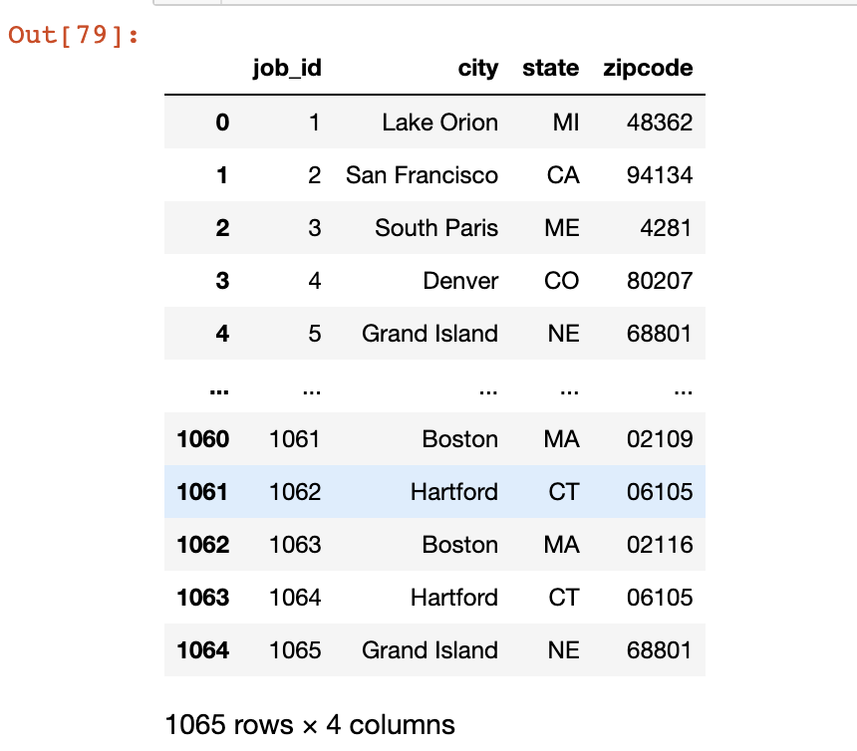

**Fig 8: 1NF table 3**

conn = sqlite3.connect('JobsFinalDatabase.db')

print("Opened database successfully");

conn.execute('''DROP TABLE IF EXISTS user_login_details;''')

conn.execute('''CREATE TABLE IF NOT EXISTS user_login_details

(

user_platform_name TEXT PRIMARY KEY ,

user_password TEXT,

user_role TEXT

);''')

print("user_login_details Table created successfully");

conn.close()

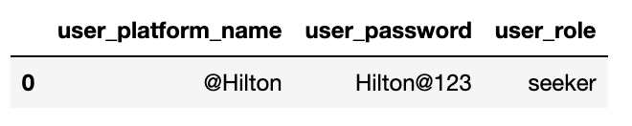

conn = sqlite3.connect('JobsFinalDatabase.db')

print("Opened database successfully");

conn.execute('''DROP TABLE IF EXISTS user_details;''')

conn.execute('''CREATE TABLE IF NOT EXISTS user_details

(

user_platform_name TEXT PRIMARY KEY ,

user_first_name TEXT,

user_last_name TEXT,

dob datetime,

mobile_number TEXT,

email_id TEXT,

portfolio_link TEXT,

FOREIGN KEY (user_platform_name) REFERENCES user_login_details(user_platform_name)

);''')

print("user_details Table created successfully");

conn.close()



conn = sqlite3.connect('JobsFinalDatabase.db')

print("Opened database successfully");

conn.execute('''DROP TABLE IF EXISTS user_skillset_details;''')

conn.execute('''CREATE TABLE IF NOT EXISTS user_skillset_details

(

user_platform_name TEXT PRIMARY KEY ,

skillset TEXT,

FOREIGN KEY (user_platform_name) REFERENCES user_details(user_platform_name)

);''')

print("user_skillset_details Table created successfully");

conn.close()

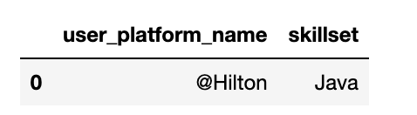

conn = sqlite3.connect('JobsFinalDatabase.db')

print("Opened database successfully");

conn.execute('''DROP TABLE IF EXISTS user_certifications;''')

conn.execute('''CREATE TABLE IF NOT EXISTS user_certifications

(

user_platform_name TEXT PRIMARY KEY ,

certification TEXT,

FOREIGN KEY (user_platform_name) REFERENCES user_details(user_platform_name)

);''')

print("user_certifications Table created successfully");

conn.close()

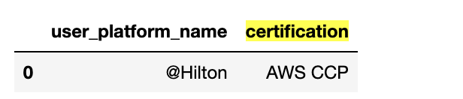

conn = sqlite3.connect('JobsFinalDatabase.db')

print("Opened database successfully");

conn.execute('''DROP TABLE IF EXISTS user_saved_jobs;''')

conn.execute('''CREATE TABLE IF NOT EXISTS user_saved_jobs

(

user_platform_name TEXT PRIMARY KEY ,

saved_application_id INTEGER,

FOREIGN KEY (user_platform_name) REFERENCES user_details(user_platform_name)

);''')

print("user_saved_jobs Table created successfully");

conn.close()

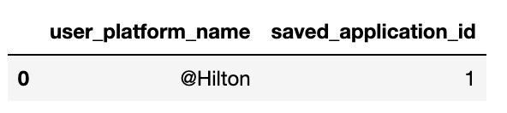

conn = sqlite3.connect('JobsFinalDatabase.db')

print("Opened database successfully");

conn.execute('''DROP TABLE IF EXISTS user_location_details;''')

conn.execute('''CREATE TABLE IF NOT EXISTS user_location_details

(

user_platform_name TEXT PRIMARY KEY ,

city TEXT,

state TEXT,

zipcode INTEGER,

FOREIGN KEY (user_platform_name) REFERENCES user_details(user_platform_name)

);''')

print("user_location_details Table created successfully");

conn.close()

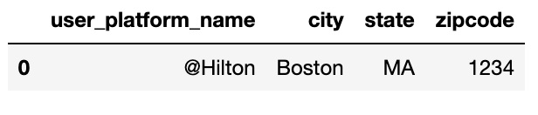

**Second Normal Form (2NF):**

Second Normal Form (2NF) is based on the concept of full functional dependency. Second Normal Form applies to relations with composite keys, that is, relations with a primary key composed of two or more attributes. A relation with a single-attribute primary key is automatically in at least 2NF.

As we are using single column reference in constructing the primary key, there is no partial dependency on the composition of the primary key but full dependent on the primary key. Hence, there are no changes in the schema from 1NF to 2 NF.

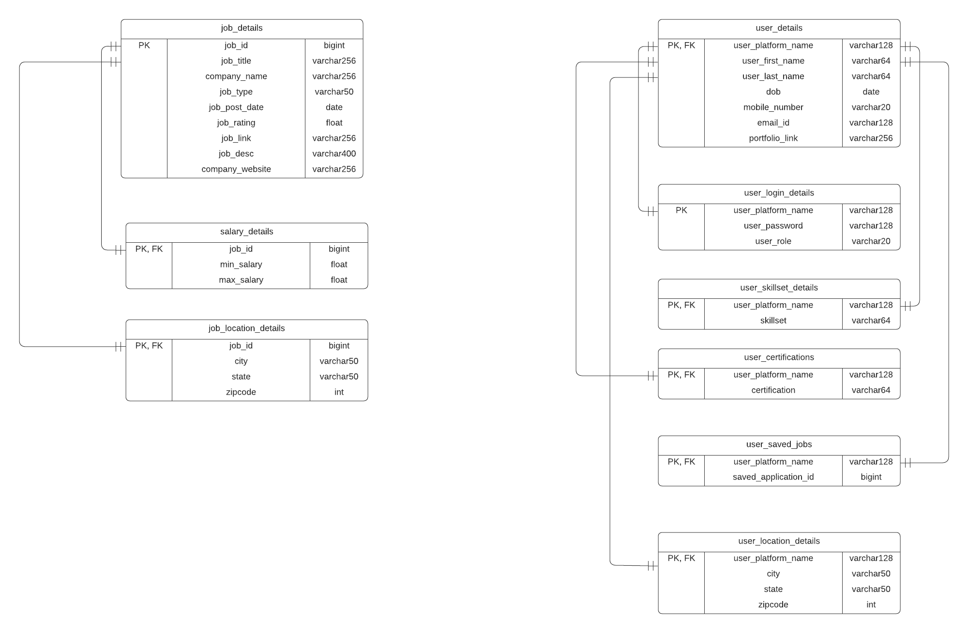

**Fig 3: 2NF Schema**

**Third Normal Form (3NF):**

A given relation is said to be in its third normal form when it's in 2NF but has no transitive partial dependency. Meaning, when no transitive dependency exists for the attributes that are non-prime, then the relation can be said to be in 3NF.

From the 2NF schema, it can be observed that company website column in the job_details table is dependent on company_name which is non candidate key. Hence, as per 3NF, the columns in the job_details table are reduced to be completely functionally dependent on the primary key and created a new table(company_details) that has company relevant information.

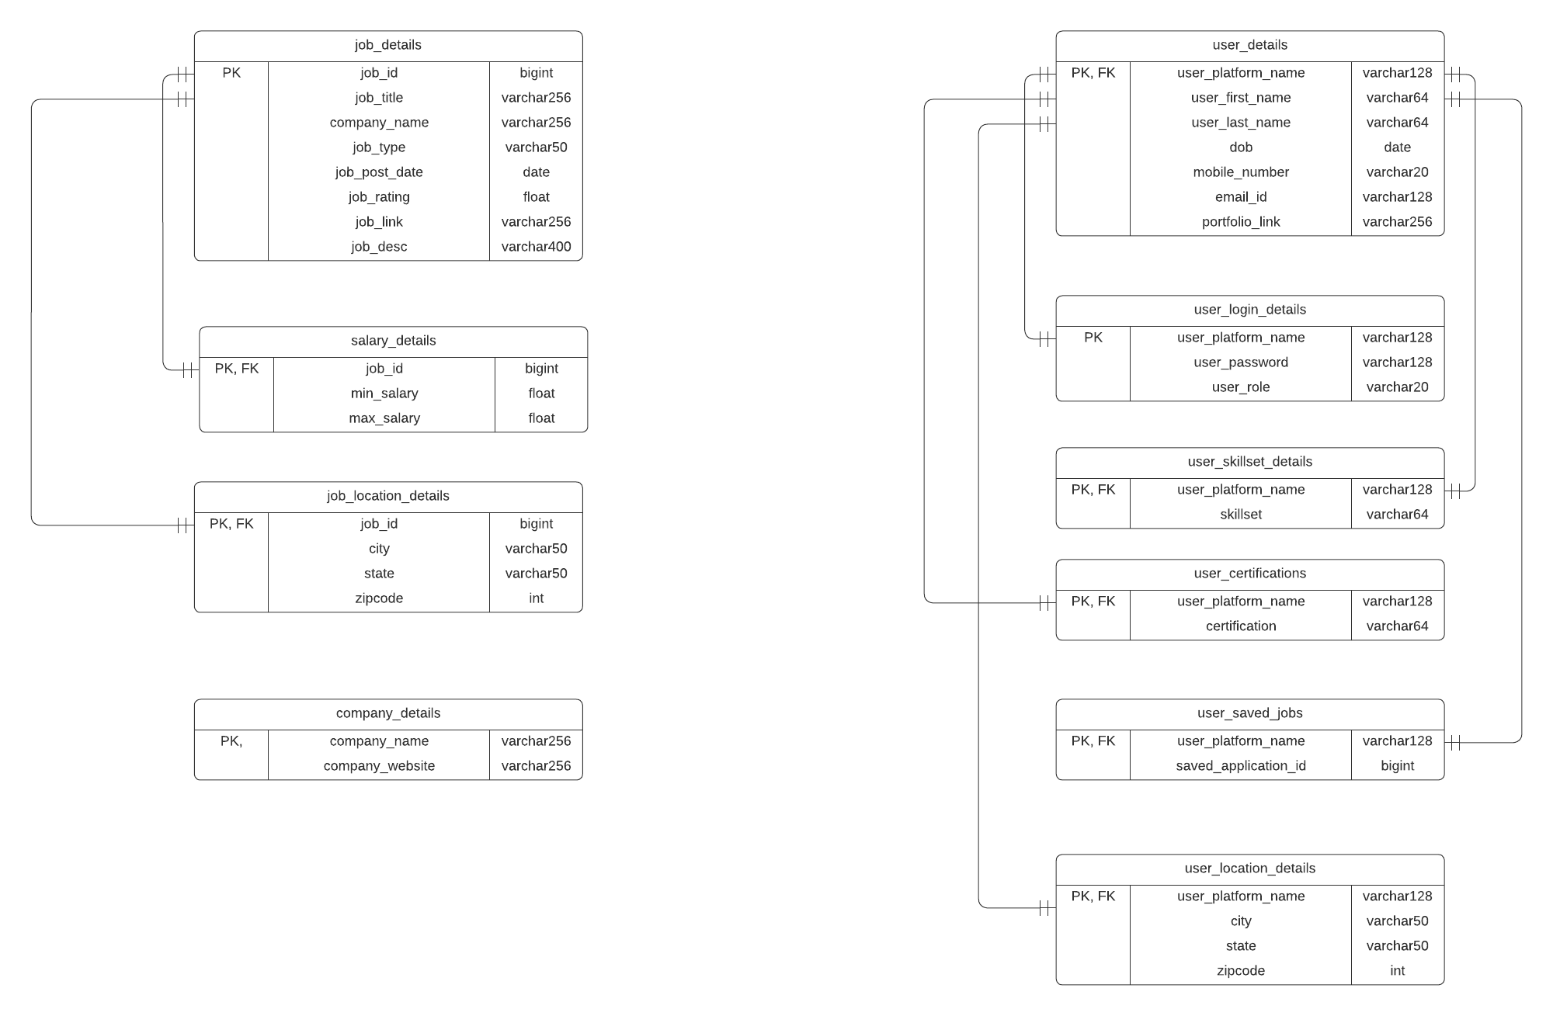

**Fig : 3NF Schema**

**Schema and table:**

conn = sqlite3.connect('JobsFinalDatabase.db')

print("Opened database successfully");

conn.execute('''DROP TABLE IF EXISTS company_details;''')

conn.execute('''CREATE TABLE IF NOT EXISTS company_details

(

company_name TEXT PRIMARY KEY ,

company_website TEXT

);''')

print("company_details Table created successfully");

conn.close()

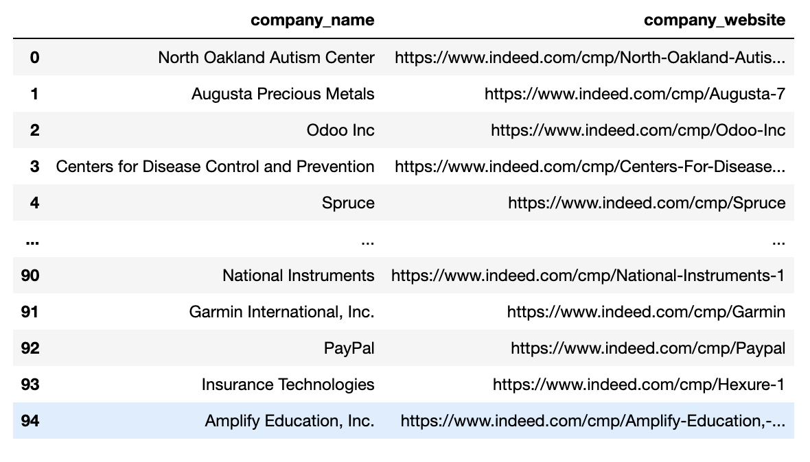

**Final Normalized Schema:**



**Fig: Final Schema**

**View for all the Use-cases:**

* **Maheswara Sai Ram Palakurthy:**

1. Create view analyst_jobs as

Select j.job_title, j.job_link, l.city || ', ' || l.state || ', ' || l.zipcode as location, s.min_salary as salary, j.job_post_date, j.job_desc, j.job_rating, j.job_type from job_details j inner join salary_details s on j.job_id = s.job_id inner join job_location_details l on j.job_id = l.job_id where j.job_title LIKE "%Analyst%";

Select * from analyst_jobs;

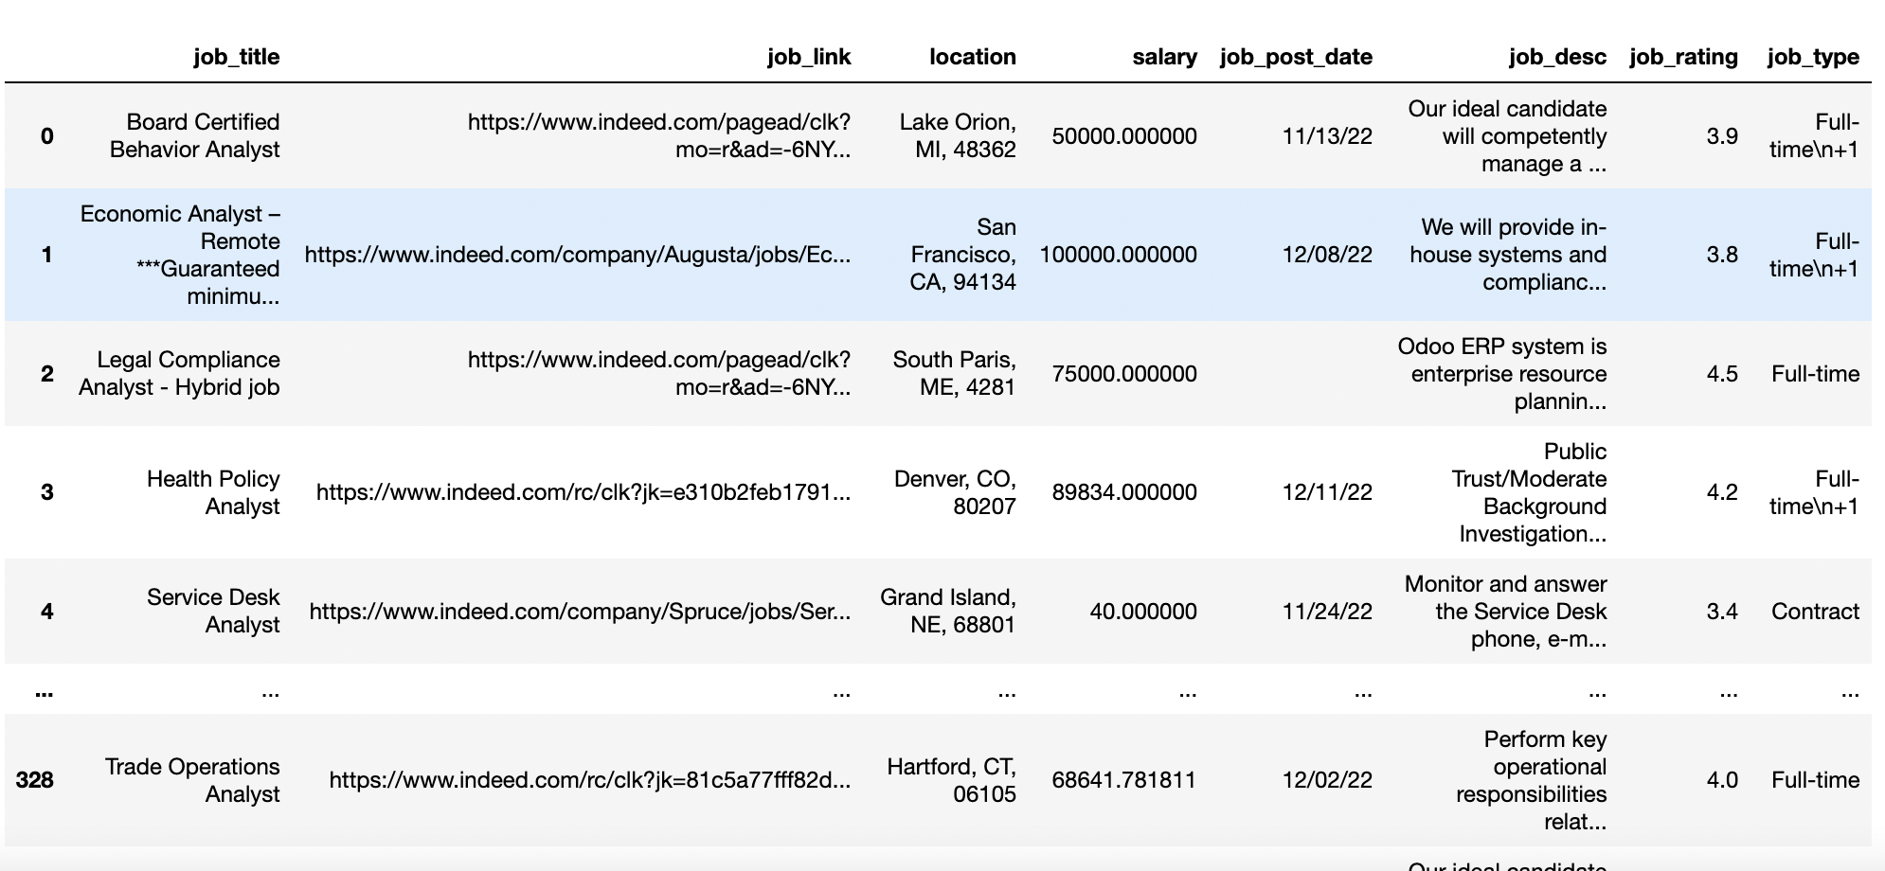

**Use Case**: Displaying the details of the job profiles for Analyst Roles.

**Description**: User can view the job profile details for the Analyst Roles.

**Actor**: User

**Precondition**: Jobs descriptions must contain details about the job profiles.

**Steps**:

**Actor action**: View job profile details for the Analyst Roles.

**System Responses**: The list of Analyst Roles Jobs are displayed to User.

Alternate Path: There are no jobs postings.

Error: No history of jobs available.

1. Create view jobs_rating as

select c.company_name, avg(j.job_rating) from company_details c inner join job_details j on c.company_name = j.company_name group by c.company_name having avg(j.job_rating) > 2.0 and avg(j.job_rating) < 4.0;

Select * from jobs_rating;

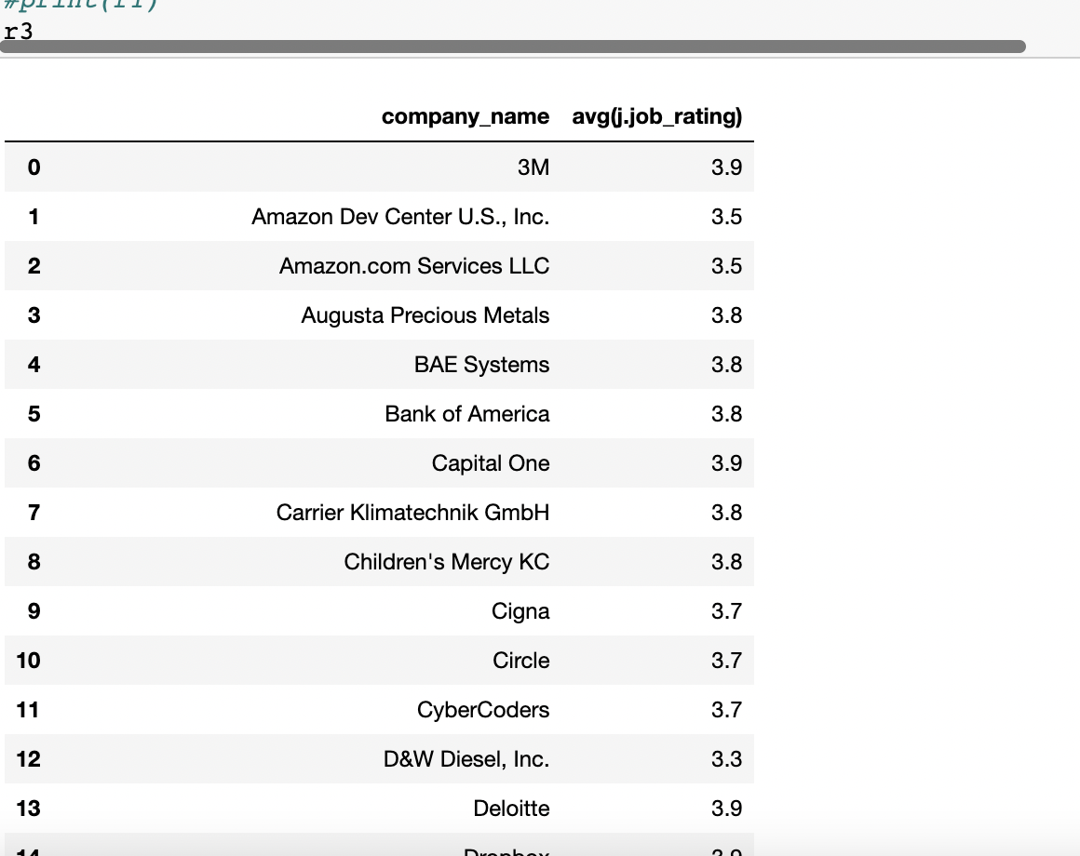

**Use Case**: Display the company names with average rating greater than 2 and less than 4.

**Description**: User can view the company names with average rating greater than 2 and less than 4.

**Actor**: User

**Precondition**: Companies should have company rating.

**Steps**:

**Actor action**: User can view the company names with average rating greater than 2 and less than 4.

**System Responses**: the company names with average rating greater than 2 and less than 4 are displayed.

Alternate Path: No company names are displayed.

Error: Job ratings data not available.

1. Create view job_location as

select c.company_name, c.company_website, l.city || ', ' || l.state || ', ' || l.zipcode as location from company_details c inner join job_details j on c.company_name = j.company_name inner join job_location_details l on j.job_id = l.job_id where l.state LIKE "%MA%";

Select * from job_location;

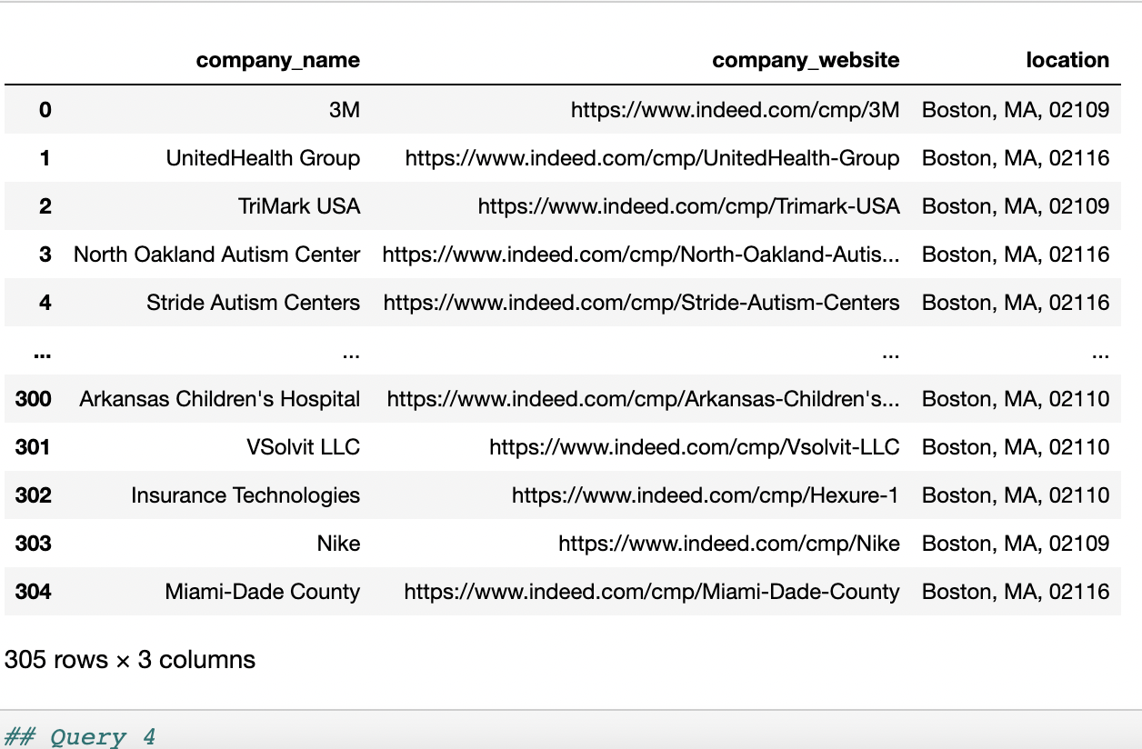

**Use Case**: List the companies that offer employment in MA state.

**Description**: User gets the list of companies that offer employment in MA state.

**Actor**: User

**Precondition**: Companies must be present in the given state.

**Steps**:

**Actor action**: View the companies that offer employment in MA state.

**System Responses**: Gives the list of companies that offer employment in MA state.

Alternate Path: No companies are present in the given state.

Error: No jobs available now.

1. Create view software_jobs as

select j.job_title, j.job_link, l.city || ', ' || l.state || ', ' || l.zipcode as location, s.min_salary as salary, j.job_rating, j.job_type from job_details j inner join salary_details s on j.job_id = s.job_id inner join job_location_details l on j.job_id = l.job_id where j.job_desc LIKE "%Software%" ORDER BY j.job_rating desc limit 5;

Select * from software_jobs;

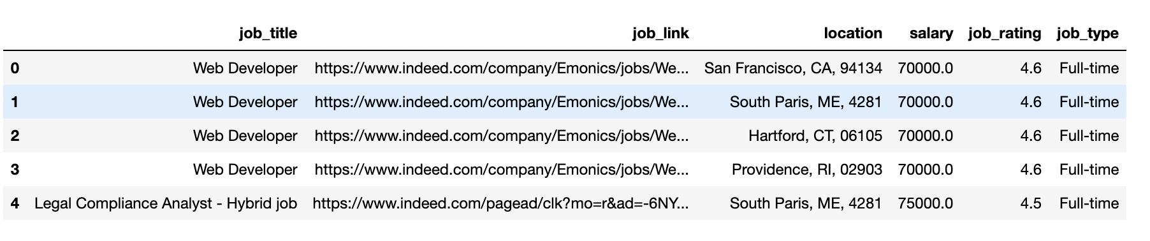

**Use Case**: Display the list of top 5 highest rated job profiles in the domain of Software Engineering.

**Description**: User views the top 5 highest rated jobs in the domain - Software Engineering. **Actor**: User

**Precondition**: Database must have the data for the jobs in the domain - Software Engineering.

**Steps**:

**Actor action**: User views the top 5 highest rated jobs.

**System Responses**: The list of top 5 highest rated job profiles in the domain of Software Engineering.

Alternate Path: There are no jobs under the domain - Software Engineering.

Error: No jobs available now.

1. Create view intern_jobs as

Select j.job_title, j.job_link, j.job_type, s.min_salary as salary from job_details j inner join salary_details s on j.job_id = s.job_id where j.job_type LIKE "%Full-time%" and j.job_title LIKE "%Intern%";

Select * from intern_jobs;

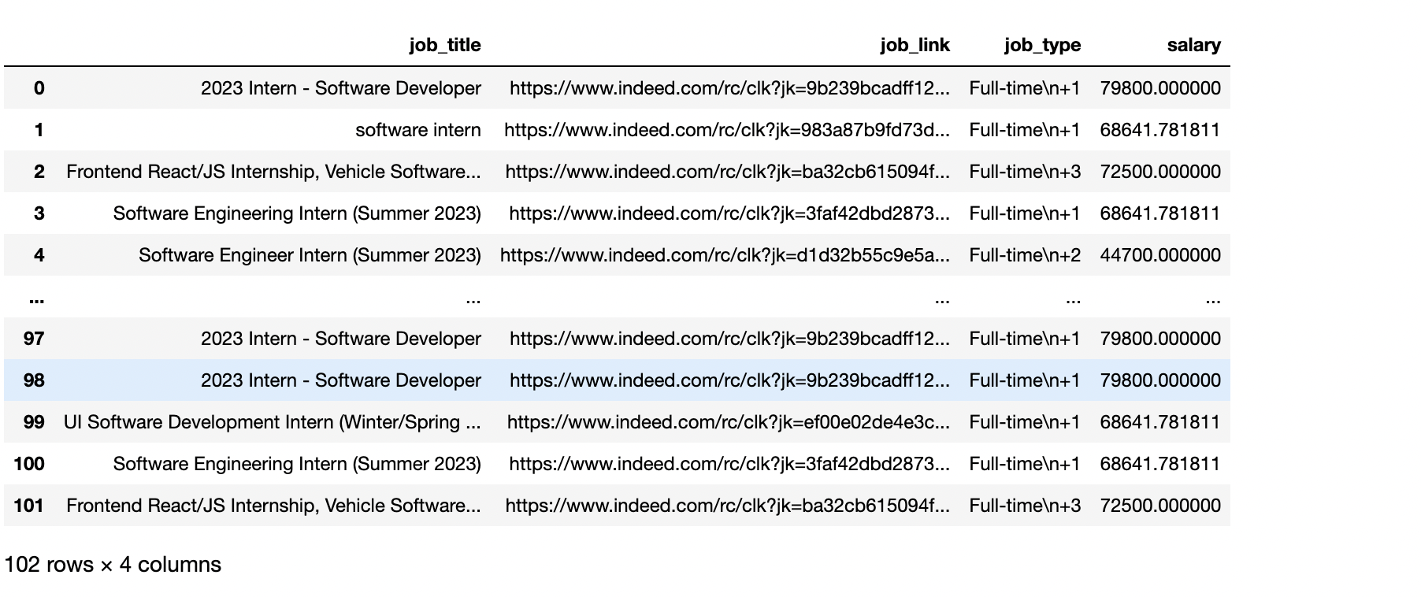

**Use Case**: List the jobs that offer Full-time opportunities for Interns.

**Description**: User views the jobs that offer Full-time opportunities for Interns.

**Actor**: User

**Precondition**: Database must have the data for the above jobs.

**Steps**:

**Actor action**: User views all the jobs that offer Full-time opportunities for Interns.

**System Responses**: The list jobs that offer Full-time opportunities for Interns.

Alternate Path: There are no jobs available.

Error: No history of jobs available.

* **Namitha J C:**

1. Create view fullstack_jobs as

Select c.company_name from company_details c inner join job_details j on c.company_name = j.company_name where j.job_title LIKE "%Full Stack%" group by c.company_name having max(j.job_rating) > 4;

Select * from fullstack_jobs;

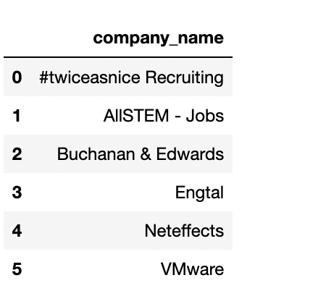

**Use Case**: Displaying the list of companies with excellent(>4.5) employee rating in the job role of Full Stack Developer.

**Description**: User can view the list of companies with excellent employee rating in the job role of Full Stack Developer.

**Actor**: User

**Precondition**: Companies must have excellent employee rating in the given job role.

**Steps**:

**Actor action**: view the list of companies with excellent employee rating in the job role of Full Stack Developer.

**System Responses**: Display the list of companies with excellent employee rating in the job role of Full Stack Developer.

Alternate Path: There are no employee rating for the given job role.

Error: No data available.

1. Create view remote_jobs as

Select j.job_title, c.company_name, j.job_link, l.city || ', ' || l.state || ', ' || l.zipcode as location, s.min_salary as salary from job_details j left join company_details c on c.company_name = j.company_name inner join salary_details s on j.job_id = s.job_id inner join job_location_details l on j.job_id = l.job_id where j.job_title LIKE "%Remote%" and s.min_salary >= 70000;

Select * from remote_jobs;

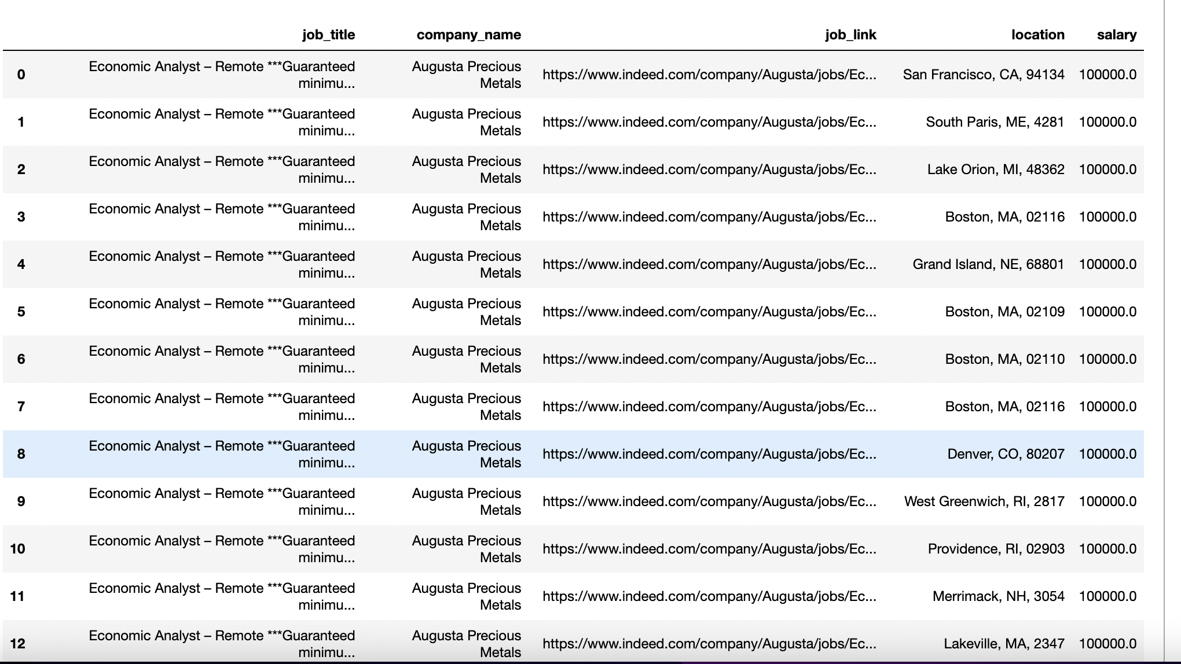

**Use Case**: Display the job profiles that offer at least $70000 for Remote jobs.

**Description**: Filter jobs based on salary - at least $70000 for the Remote jobs.

**Actor**: User

**Precondition**: Jobs must have salary of at least $70000 for the given role.

**Steps**:

**Actor action**: View the job profiles that offer at least $70000 for the Remote jobs**.**

**System Responses**: Display all the jobs with salary at least $70000 for the given role.

Alternate Path: No jobs are Displayed.

Error: Data unavailable.

1. Create view jobs_location as

Select j.company_name, j.job_type, l.city || ', ' || l.state || ', ' || l.zipcode as location from job_details j inner join job_location_details l where j.job_type = "Internship" and l.city LIKE "%Boston%";

Select * from jobs_location;

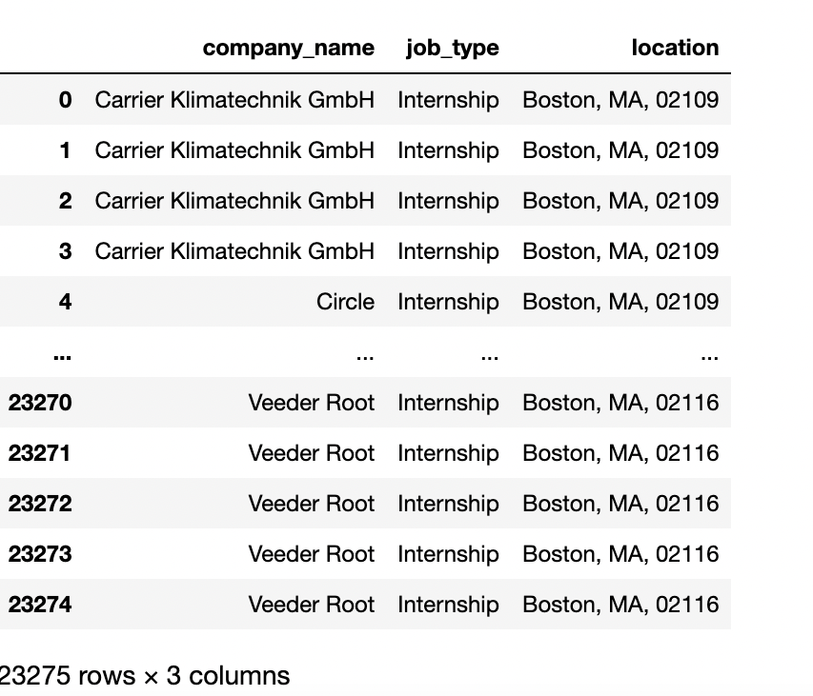

**Use Case**: List the company urls that offer Internships in location Boston.

**Description**: Displays the company urls for the given conditions.

**Actor**: User

**Precondition**: Company urls must be present.

**Steps**:

**Actor action**: User can view the list of company urls that offer Internships in location Boston.

**System Responses**: Display the list of company urls for the given conditions.

Alternate Path: No urls are displayed.

Error: Data currently unavailable.

1. Create view developer_jobs as

Select j.job_title, AVG(j.job_rating), c.company_name from job_details j inner join company_details c on j.company_name = c.company_name where j.job_title LIKE "%Developer%" group by j.job_title, c.company_name;

Select * from developer_jobs;

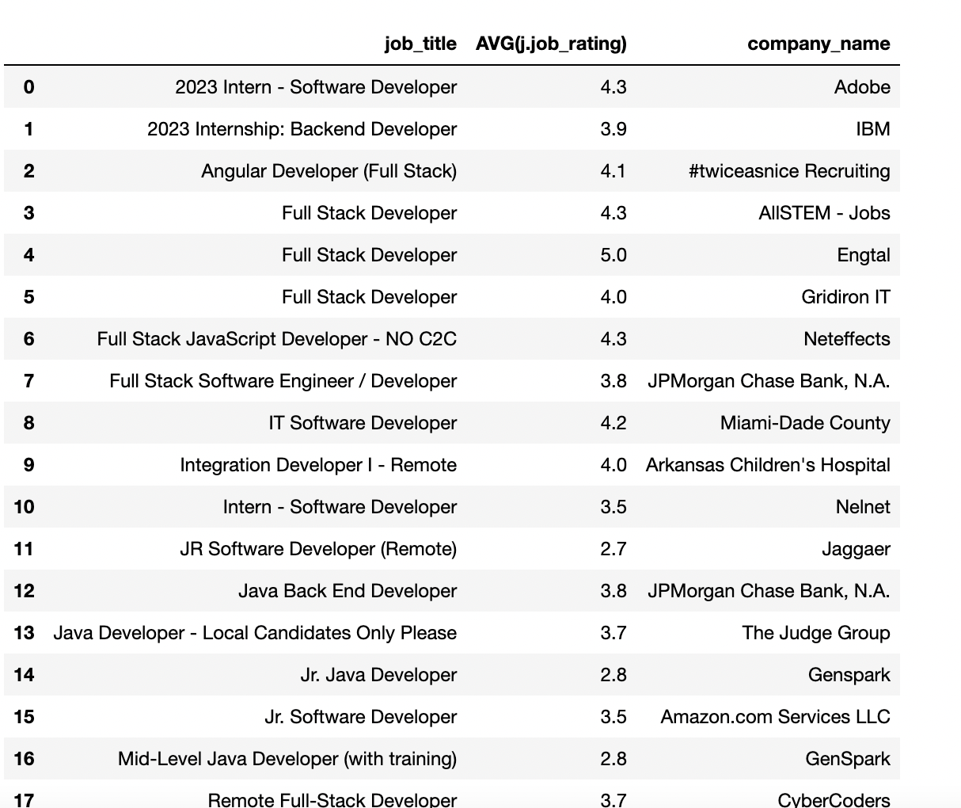

**Use Case**: List the mean(rating) of the jobs available for the role of Developer.

**Description**: User can view the mean rating of the jobs available for the role of Developer.

**Actor**: User

**Precondition**: Jobs postings must contain ratings.

**Steps**:

**Actor action**: View listed jobs.

**System Responses**: The list of mean(rating) of the jobs available for the role of Developer.

Alternate Path: There are no ratings for the given jobs.

Error: No history of jobs available.

1. Create view software_engineer_jobs as

Select l.city || ', ' || l.state || ', ' || l.zipcode as Location from job_location_details l inner join job_details j on l.job_id = j.job_id where j.job_type = "Internship" and j.job_title LIKE "%Software Engineer%";

Select * from software_engineer_jobs;

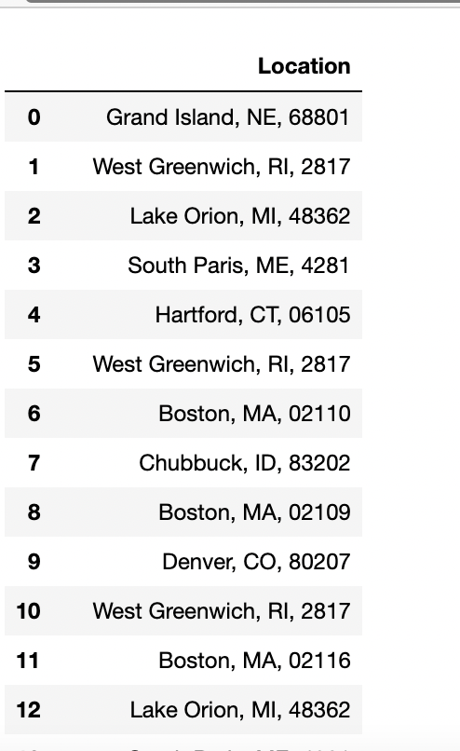

**Use Case**: List all the locations where Internship opportunities are offered in the role of Software Engineer.

**Description**: User can view the list of locations for the given conditions.

**Actor**: User

**Precondition**: Internship opportunities must be available at the given locations.

**Steps**:

**Actor action**: User can view the list of locations for the given conditions.

**System Responses**: Lists all the locations where Internship opportunities are offered in the role of Software Engineer.

Alternate Path: Internship opportunities data not available at the given locations.

Error: Data not available.

* **Sinchana Kumara:**

1. Create view finance_jobs as

Select j.job_link as URL from job_details j where job_title LIKE "%Java%" UNION Select c.company_website as URL from company_details c where c.company_name LIKE "%Cigna%";

Select * from finance_jobs;

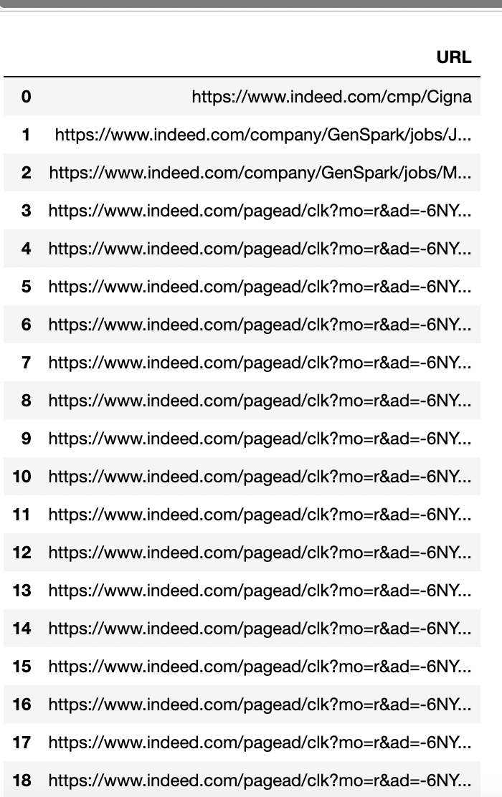

**Use Case**: List the Job URLs for the job role Java and the job URLs available from a company Cigna.

**Description**: User views the job urls for the given conditions.

**Actor**: User

**Precondition**: Jobs urls must be present in the database.

**Steps**:

**Actor action**: User views all the job urls for the given conditions.

**System Responses**: The list of Job URLs for the job role Java and the job URLs available from a company Cigna.

Alternate Path: There are no job urls present in the database.

Error: No data available.

1. Create view user_skillset as

Select j.job_title, j.job_link, s.min_salary as salary from job_details j inner join salary_details s on j.job_id = s.job_id where j.job_title LIKE "%Co-op%" group by j.job_title,s.min_salary, j.job_link having avg(j.job_rating) > 3.0;

Select * from user_skillset;

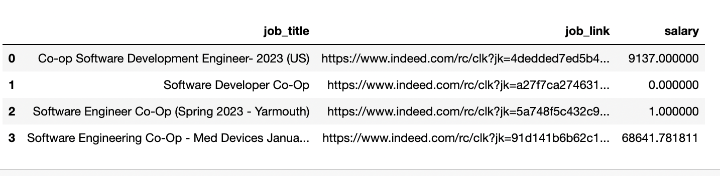

**Use Case**: Display the list of jobs having hashtags with user_platform_name is “@Hilton”.

**Description**: Display data for above given condition.

**Actor**: User

**Precondition**: “@Hilton” should be present in the database.

**Steps**:

**Actor action**: User can view the list of jobs with the given conditions.

**System Responses**: Display all the jobs with the given conditions.

Alternate Path: No data is displayed.

Error: Data unavailable.

1. Create view jobs_postings as

Select j.job_title, j.job_link, s.min_salary as salary from job_details j inner join salary_details s on j.job_id = s.job_id where j.job_post_date >= DATE("now", "-30 day");

Select * from jobs_postings;

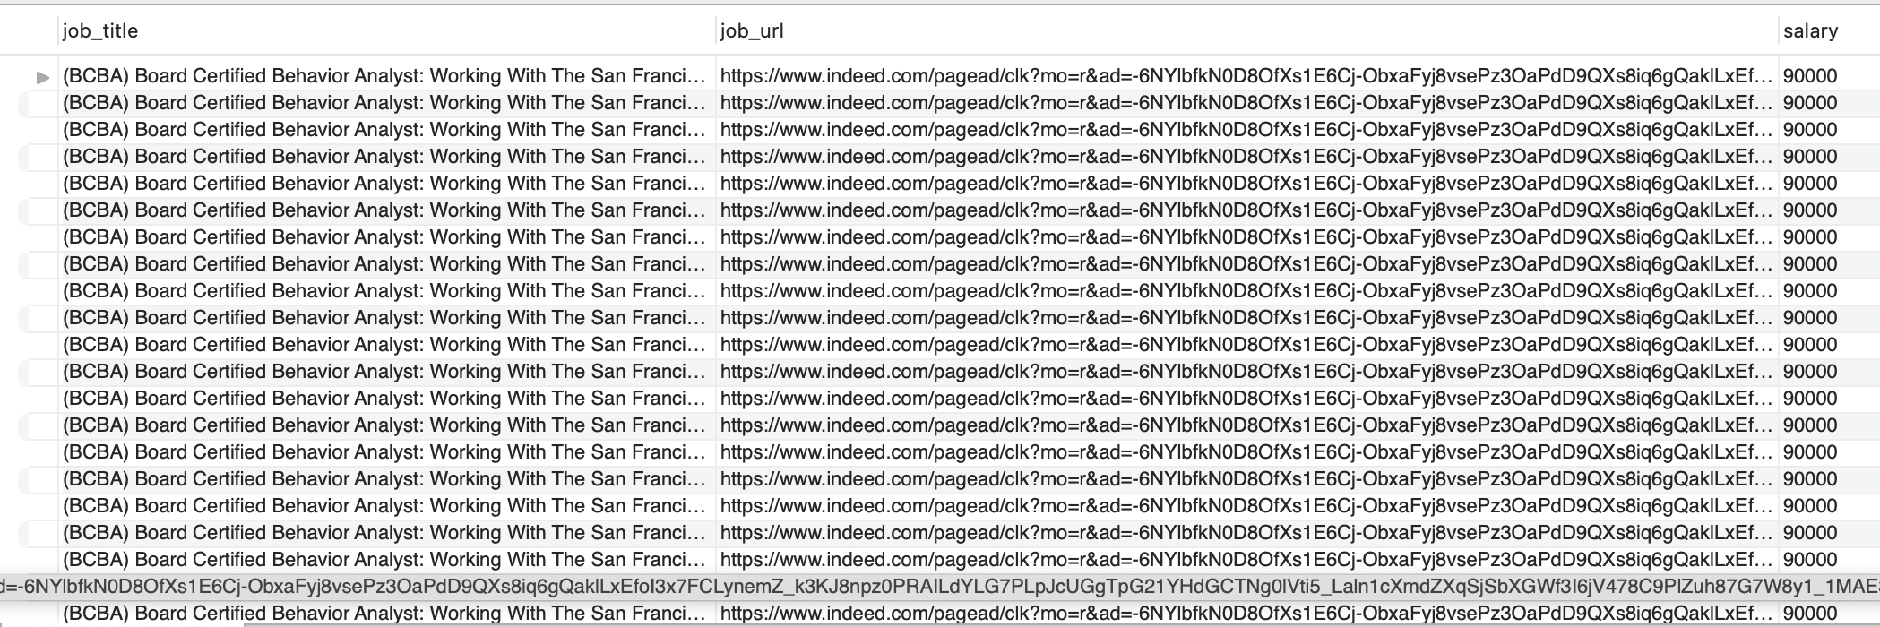

**Use Case**: Provide the job listings that was posted 7 days ago.

**Description**: User can view the Job posted 7 days ago.

**Actor**: User

**Precondition**: Jobs postings must contain posted date.

**Steps**:

**Actor action**: View the Job posted 7 days ago.

**System Responses**: Display the list of jobs posted 7 days ago.

Alternate Path: No Jobs are available.

Error: No history of jobs available.

1. Create view job_roles as

Select j.job_title, l.city || ', ' || l.state || ', ' || l.zipcode as location, j.job_desc, j.job_type from job_details j inner join job_location_details l on j.job_id = l.job_id where j.job_type = "Contract";

Select * from job_roles;

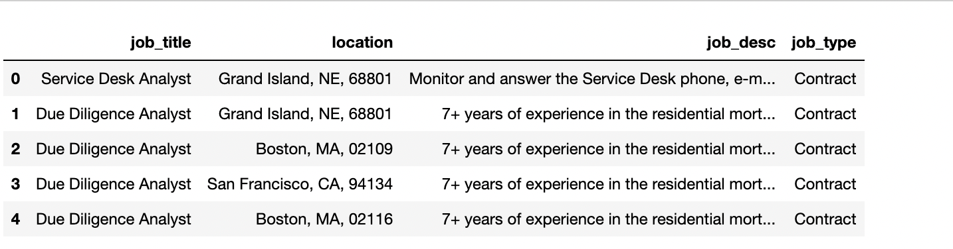

**Use Case**: Display the job description of the roles that offer Contract opportunities.

**Description**: User can view the job descriptions with the given conditions.

**Actor**: User

**Precondition**: Job descriptions must be present in the database.

**Steps**:

**Actor action**: User can view the job descriptions with the given conditions.

**System Responses**: Display the job description of the roles that offer Contract opportunities.

Alternate Path: No data available.

Error: Job description data not available.

1. Create view software_engg_jobs as

Select j.job_title, j.job_link, c.company_website, j.job_type, s.min_salary as salary, l.city || ', ' || l.state || ', ' || l.zipcode as location from job_details j inner join company_details c on j.company_name = c.company_name inner join salary_details s on j.job_id = s.job_id inner join job_location_details l on j.job_id = l.job_id where l.state LIKE "%MA%" and j.job_title LIKE "%Software%";

Select * from software_engg_jobs;

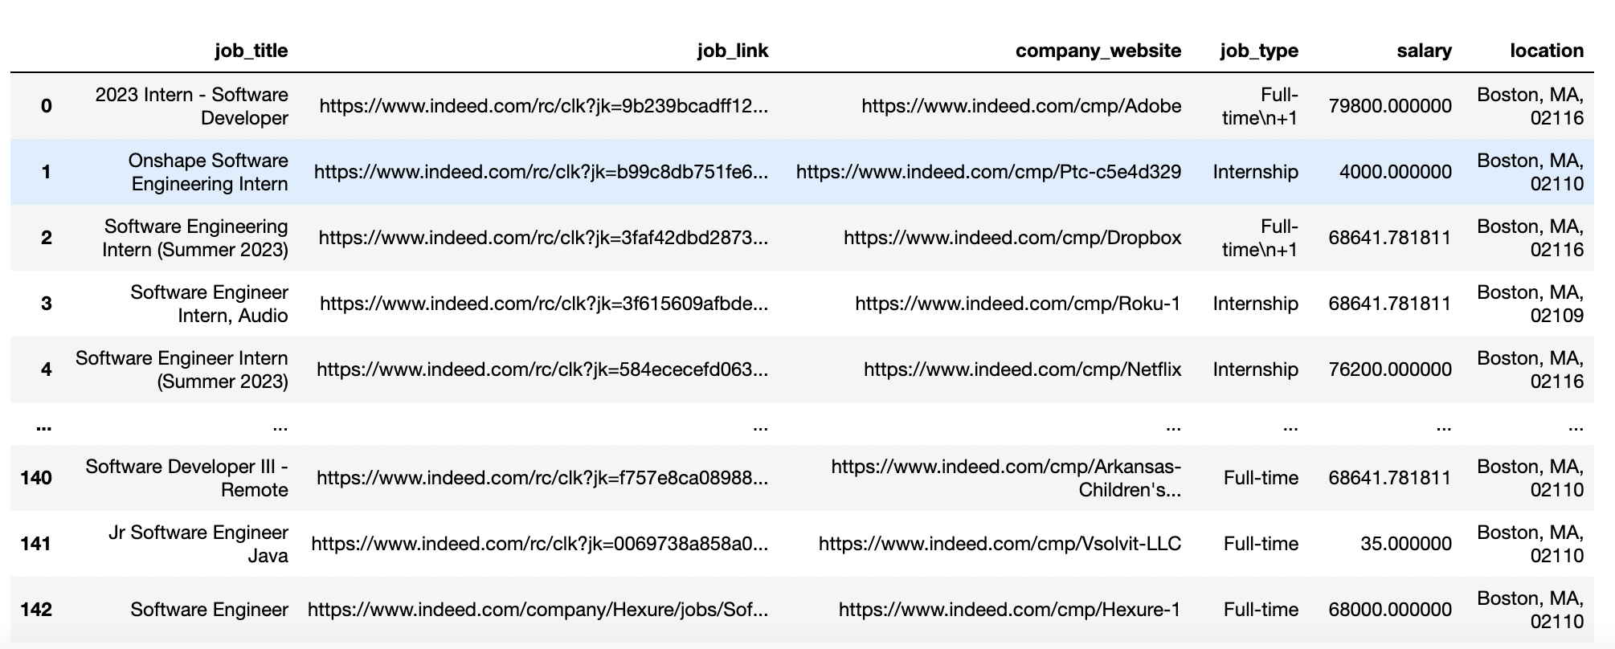

**Use Case**: List the job urls, company urls, job_type from a role Software and location is MA.

**Description**: User will be able to view the job urls, company urls, job_type for the given role and location.

**Actor**: User

**Precondition**: Urls must be present in the given database.

**Steps**:

**Actor action**: User views all the job urls, company urls, job_type for the given role and location.

**System Responses**: Lists the job urls, company urls, job_type from a role Software and location is MA.

Alternate Path: There are no job urls present.

Error: No history of data available.